**UNIX LAB**

**Assignment 4**

**Name:** Iyer Sreekesh Subramanian **Class/Roll No.** D10A/24

**Aim:** To execute Memory Management Commands in Linux Shell  
  
**Commands:**

**free**free is a command line utility for checking the amount of free space available along with the amount of memory used and swap memory in the system, along with the buffers used by the Kernel.

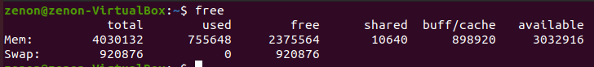

**proc**It is a virtual file system created on the fly when the system is booted, dissolved at the time of shut down. It contains information about currently running processes, thus regarded as a control and information center for the kernel.   
  
*proc/meminfo* is used to report the free and used memory, both physical and swap, along with the shared memory and buffers used by Linux Kernel.

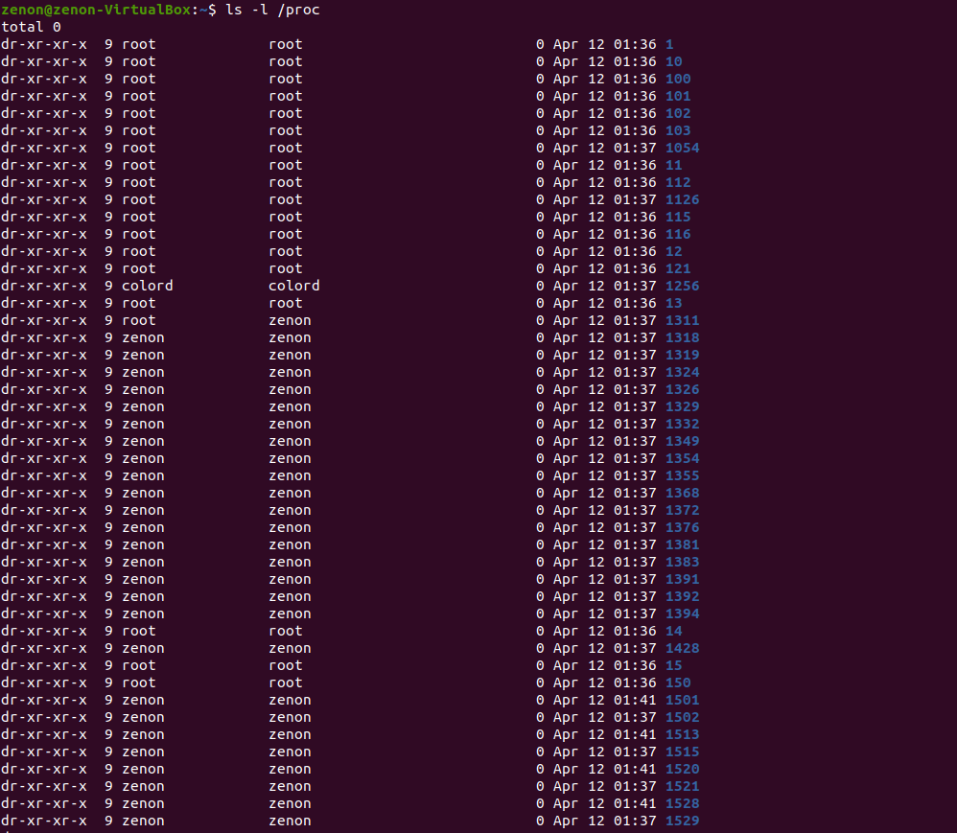

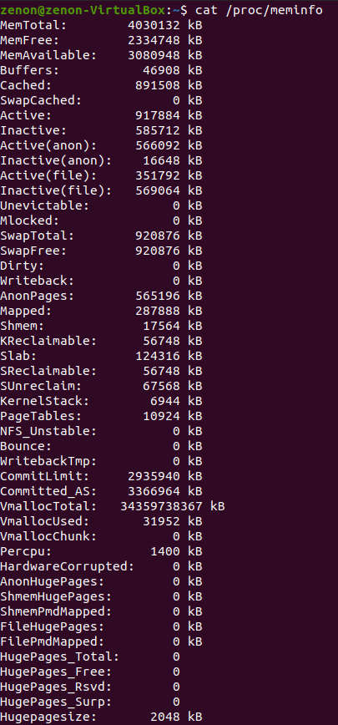

**top:**top command is used to show the Linux Processes. It provides a dynamic real-time view of the running system. Usually, this command shows the summary information of the system and the list of processes or threads which are currently managed by the Kernel.

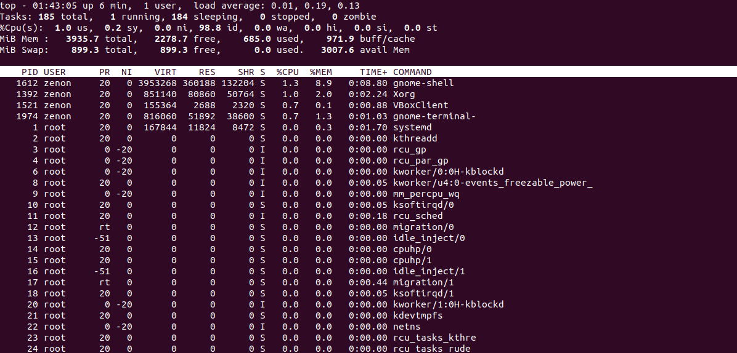

**htop:**  
It’s a command line utility which allows the user to interactively monitor the system’s vital resources or server’s processes in real time. It’s newer and released after top, offers many improvements over the top command.

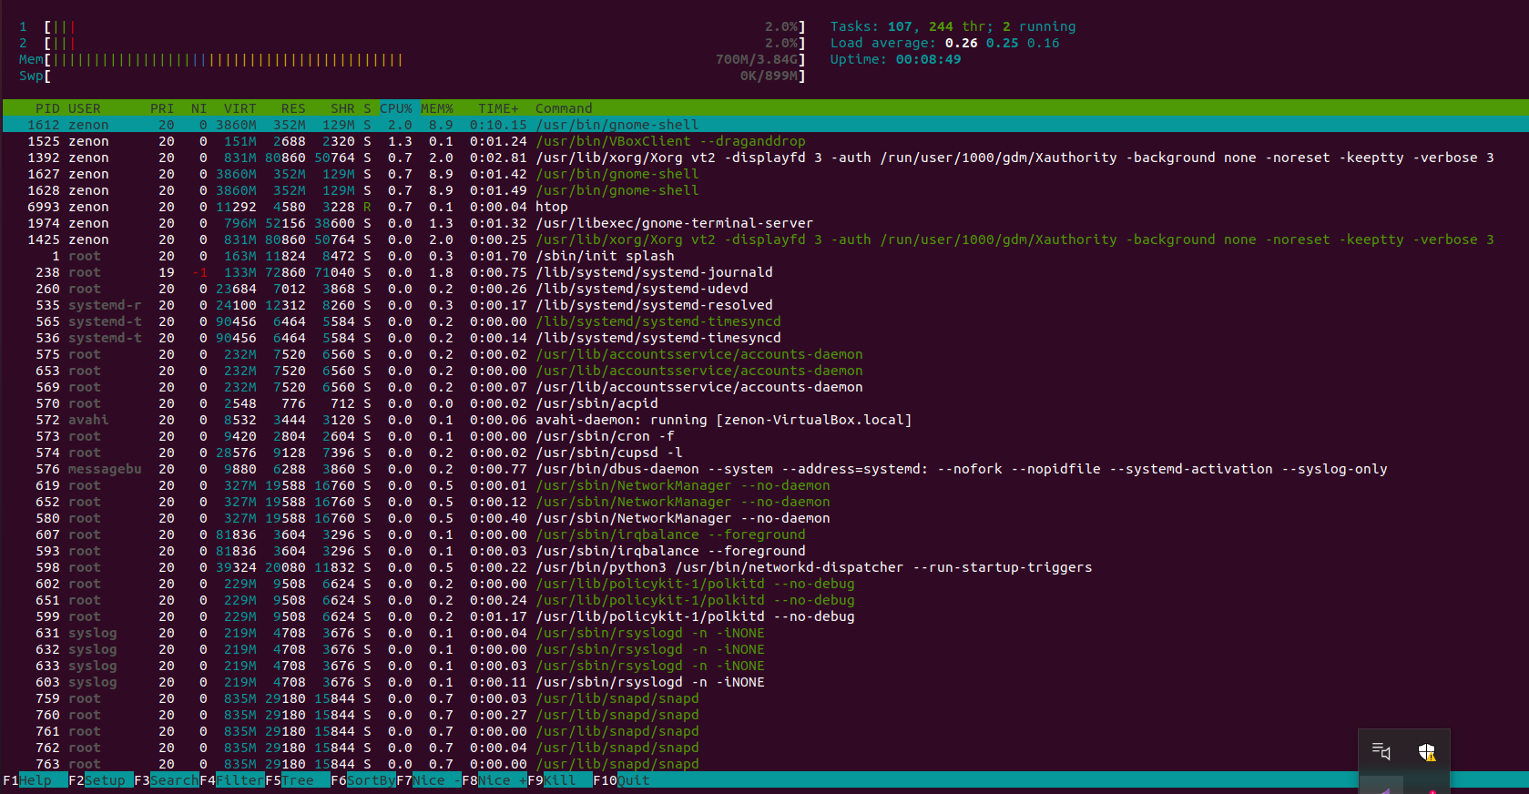

**df:**The df command (short for disk free), is used to display information related to file systems about total space and available space.

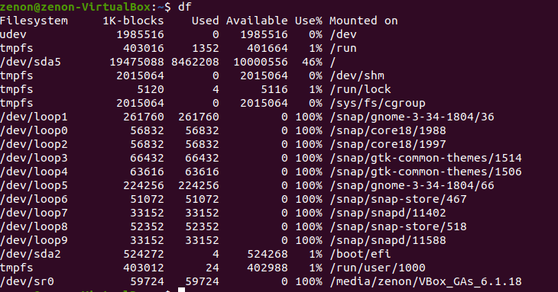

**du:**It’s short for disk usage, used for estimating file space usage. Generally used to track files and directories consuming excessive amount of storage.   
  
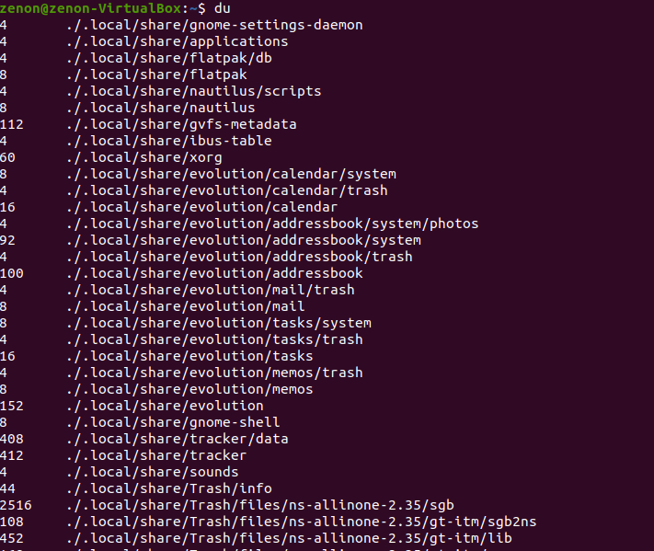

**vmstat:**vmstat in Linux is a performance monitoring command of the system as it gives the information about processes, memory, paging, block IO, disk and CPU scheduling. All these functionalities make the command vmstat also known as virtual memory statistic reporter.   
  
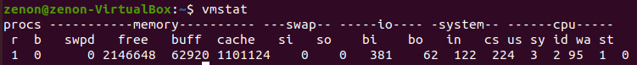

**dmidecode:**dmidecode also referred to as Desktop Management Interface table decoder, records data from DMI tables and produces it in human readable format. dmidecode command is used when the user wants to retrieve system’s hardware related information such as Processor, RAM, details of BIOS, Memory, Serial Numbers etc. of Linux system in a readable format. dmidecode command not only displays the system’s current hardware configuration but also the maximum supported CPU and memory.

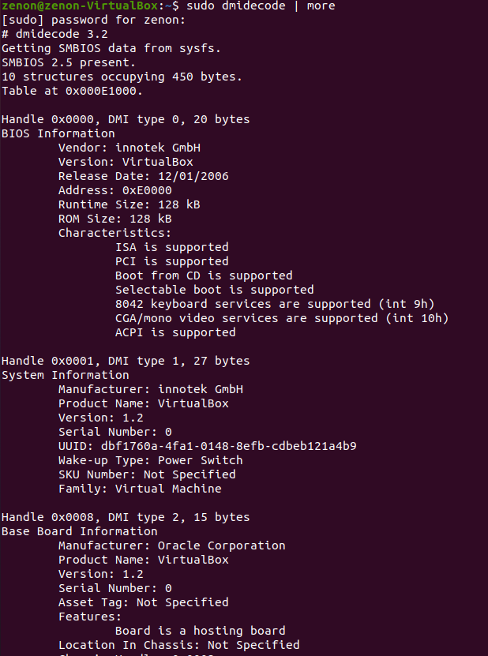

**sar:**(System Activity Report) It can be used to monitor Linux system resources like CPU usage, Memory utilization, I/O devices consumption, Network Monitoring, Disk Usage, process and thread allocation, battery performance, Plug and Play devices, etc. Linux system Monitoring and analyzing aids understanding system resource usage which can help to improve system performance to handle more requests. By default SAR command displays the result on the output screen, in addition the result can also be stored in the file specified by the -o filename option.

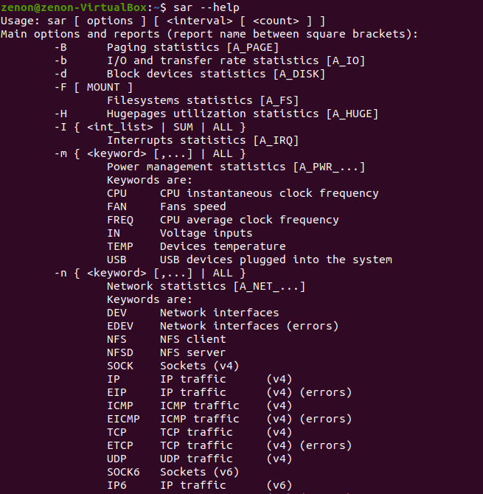  
**pagesize:**Most modern operating systems have their main memory divided into pages. It allows better utilization of memory. A page is a fixed length block of main memory, that is contiguous in both physical memory addressing and virtual memory addressing.  
  


**smem:**  
smem is a tool that can provide numerous reports of memory usage on Linux systems. Unlike existing tools, smem can report Proportional Set Size (PSS), Unique Set Size (USS) and Resident Set Size (RSS).  
  
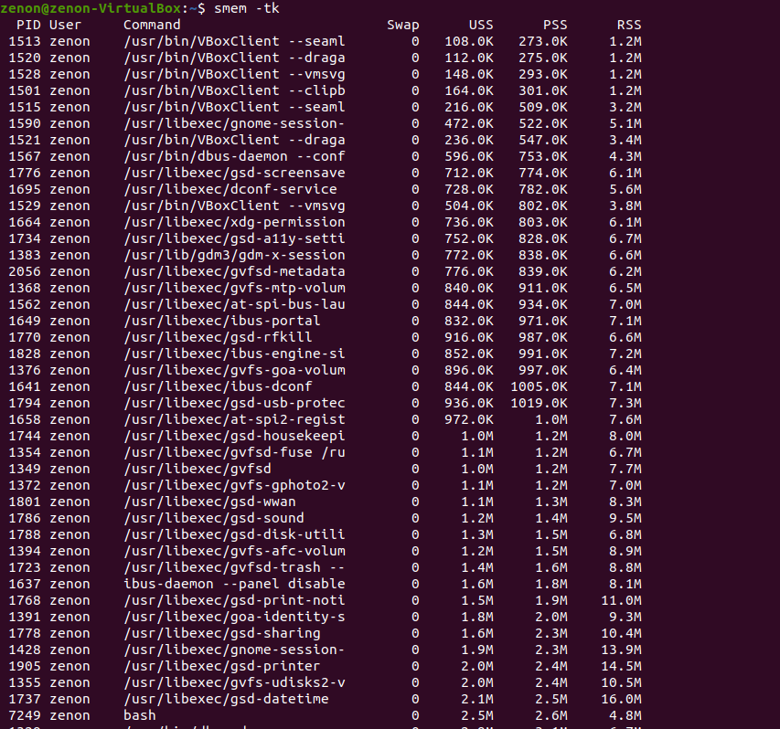

**glances:**  
glance is a free tool and licensed under GPL to monitor GNU/Linux and FreeBSD operating systems. There are lots of interesting options available in Glances as well. One of the main features we have seen in Glances is that we can set thresholds (careful, warning and critical) in configuration files and information will be shown in colors which indicates the bottleneck in the system.

